Tunisia

## GNI per capita and development level

The data set shows the GNI per capita and development level of the country each year.

## # A tibble: 19 x 5  
## country iso3c date GNIperCapita devCategory   
## <chr> <chr> <dbl> <dbl> <chr>   
## 1 Tunisia TUN 1996 2447. Lower Middle Income  
## 2 Tunisia TUN 1998 2667. Lower Middle Income  
## 3 Tunisia TUN 2000 2892. Lower Middle Income  
## 4 Tunisia TUN 2002 2997. Lower Middle Income  
## 5 Tunisia TUN 2003 3122. Lower Middle Income  
## 6 Tunisia TUN 2004 3286. Lower Middle Income  
## 7 Tunisia TUN 2005 3340. Lower Middle Income  
## 8 Tunisia TUN 2006 3495. Lower Middle Income  
## 9 Tunisia TUN 2007 3660. Lower Middle Income  
## 10 Tunisia TUN 2008 3755. Lower Middle Income  
## 11 Tunisia TUN 2009 3855. Lower Middle Income  
## 12 Tunisia TUN 2010 3948. Lower Middle Income  
## 13 Tunisia TUN 2011 3824. Lower Middle Income  
## 14 Tunisia TUN 2012 3955. Lower Middle Income  
## 15 Tunisia TUN 2013 4009. Lower Middle Income  
## 16 Tunisia TUN 2014 457. Low Income   
## 17 Tunisia TUN 2015 10033. Upper Middle Income  
## 18 Tunisia TUN 2016 457. Low Income   
## 19 Tunisia TUN 2017 457. Low Income

## GDP growth and economic growth classification

The data set shows the GDP growth and the ecomic growth classification of the country each year.

## # A tibble: 19 x 5  
## country iso3c date GDPannualGrowthRate GDPgrowthCategory4  
## <chr> <chr> <dbl> <dbl> <fct>   
## 1 Tunisia TUN 1996 7.15 fast growth   
## 2 Tunisia TUN 1998 4.78 moderate growth   
## 3 Tunisia TUN 2000 4.71 moderate growth   
## 4 Tunisia TUN 2002 1.32 slow growth   
## 5 Tunisia TUN 2003 4.70 moderate growth   
## 6 Tunisia TUN 2004 6.24 fast growth   
## 7 Tunisia TUN 2005 3.49 moderate growth   
## 8 Tunisia TUN 2006 5.24 moderate growth   
## 9 Tunisia TUN 2007 6.71 fast growth   
## 10 Tunisia TUN 2008 4.24 moderate growth   
## 11 Tunisia TUN 2009 3.04 moderate growth   
## 12 Tunisia TUN 2010 3.51 moderate growth   
## 13 Tunisia TUN 2011 -1.92 negative grwoth   
## 14 Tunisia TUN 2012 4.00 moderate growth   
## 15 Tunisia TUN 2013 2.88 moderate growth   
## 16 Tunisia TUN 2014 2.97 moderate growth   
## 17 Tunisia TUN 2015 1.19 slow growth   
## 18 Tunisia TUN 2016 1.16 slow growth   
## 19 Tunisia TUN 2017 1.92 slow growth

## Development trend

The plot shows the development trend of the country.

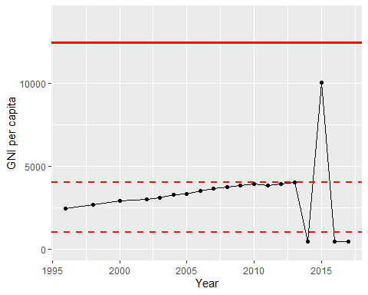

GNI Per Capita Trend